**Patent Draft**

**Submitted by:**

Group 49 CS

Srijan Shahi

Suraj Gupta

Sushant Kumar Pandey

**Title**: Virtual Assistant

**Field of Invention**: Automation

* Natural Language Processing (NLP)
* Natural Language Generation (NLG): NLG is the opposite of NLP. It involves using algorithms to generate natural language responses to user inputs. This technology is used to enable virtual assistants to provide human-like responses to user questions and commands.
* Integration with other technologies: Virtual assistants must interact with other technologies to provide a seamless user experience. For example, a virtual assistant might be integrated with a user's calendar or email to provide reminders or schedule appointments.

**Background:**

A personal voice assistant has become the main part of our daily life. It is because of the advancement of technology and all the features that an assistant provides. When Artificial Intelligence interacts with machines, then machines behave like humans. In this project, the user is just expected to give voice commands, and the rest of the work is done by our voice assistants which can automate the complete process and complete our task. Virtual Assistants perform tasks as a human can. It can send emails, play music, and talk to you accordingly. In this project, we’ll use many of the APIs with different functionalities like speech recognition API which will convert speech into text, Message Bird Voice Chat API which will make and receive calls, Viber voice chat API can shift between conversations, block/unblock conversations, Turn On/Off notifications, and much more. To build this functionality, we will use different libraries and modules like Tkinter, Web browser, Ecapture, Pyjokes, Datetime, Twilio, Requests, pyPDF2, pyautogui, pyQt, and BeautifulSoup, and at the end, we will create a live GUI for interacting with the JARVIS as it gives interesting look while having the conversation. So, utilizing these features of personal voice assistants will save a lot of time and effort.

**Objective:**

* The objective of the software is to provide users with a convenient and efficient way to perform daily tasks and access information on their desktop computers.
* The goal is to improve user productivity, streamline daily tasks, and provide a more intuitive and user-friendly interface for interacting with technology. Additionally, a desktop virtual assistant can help users save time and reduce cognitive load, making it easier for them to focus on more important tasks and responsibilities.

**Flowcharts:**

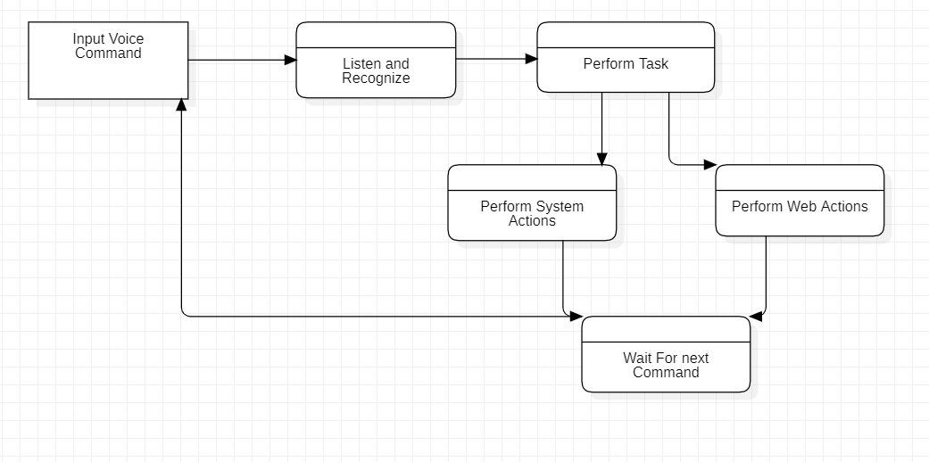

**Claims:**

* Business professionals and office workers who want to increase productivity and streamline their workflow.
* Students who need assistance with scheduling, time management, and research.
* Individuals with disabilities or impairments that make it difficult to interact with a computer using a mouse or keyboard.
* To answer general queries of visitors regarding the organization and its facilities.

**Technology Used:**

* **Pyttsx3**: It is a Python library that converts text to speech.
* **Speech Recognition**: It is a Python module that converts speech to text.
* **pywhatkit:** It is a Python library that sends WhatsApp messages at a particular time with additional features.
* **Wikipedia:** It is a Python module for searching anything on Wikipedia.
* **Smtplib:** Simple mail transfer protocol that allows us to send emails and route mail between mail servers.
* **Web browser:** It provides an interface for displaying web-based documents to users.
* **Pyautogui:** It is a Python library for the graphical user interface.
* **Os:** It represents Operating System-related functionality.

**Abstract:**

* The Desktop Virtual Assistant is a software system designed to assist users with daily tasks, such as setting reminders and performing web searches, answering queries as a help desk system, etc. The software is developed to be user-friendly and easy to interact with, using natural language processing to understand user commands and respond with relevant information and actions.
* The software is intended for desktop computers and can be customized to meet specific needs, from individual users to organizations.

**End Users:**

* **Students**: Students who need assistance with scheduling, time management, and research.
* **Organizations**: To answer general queries of visitors regarding the organization and its facilities.

**Advantage:**

* Improve user productivity.
* Streamline daily tasks.
* User-friendly interface
* Saves time.
* Reduce cognitive load.

**Summary/Conclusion:**

* A voice assistant, without any doubt, saves time for the end users through conversational interactions, effectiveness, and efficiency.
* While working on this project, I had some limitations and realized some scope for enhancement in the future.